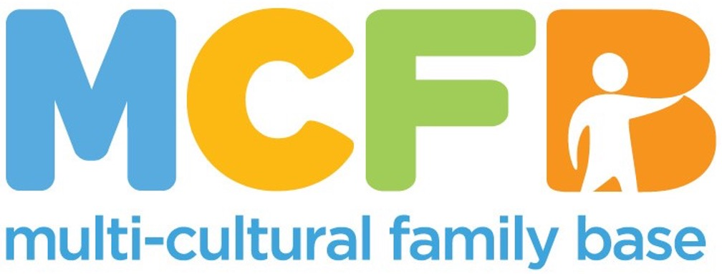
JOB PACK

This is a pack that gives the job description and other information about our organisation. In order to apply, please complete the attached “Application Pack.”

ABOUT THE MULTI-CULTURAL FAMILY BASE
The Multi-Cultural Family Base (MCFB) was established in Leith in 1998. We started because there was a recognition that there was a lack of holistic family support for diverse families in Edinburgh. Over the years we have expanded our projects in terms of age and geographical reach.

Our Values
Multi-Cultural Family Base is committed to promoting human rights, valuing diversity, providing equal opportunities and working in a way which is flexible, respectful, caring and empowering. Multi-Cultural Family Base is committed to involving users and stakeholders in service planning and provision.
We believe that community-based services for diverse families should be easy to access and able to respond to a wide range of needs. Our services include therapeutic groupwork and one-to-one casework. For more information go to: www.mcfb.org.uk

We believe that community-based services for diverse families should be easy to access and able to respond to a wide range of needs. Our services include therapeutic groupwork and one-to-one casework. For more information go to: www.mcfb.org.uk

ABOUT THE ROLE
Post Title: Finance Controller/Admin
Hours: 21 hours a week
Pay: £45,000 - £50,000 FTE
Base: Flexible/Hybrid - Must be willing to travel to the Edinburgh office 1.5 days
a week
5-7 Montgomery Street Lane, Edinburgh, EH7 5JT

Reports to: Chief Executive Officer

EMPLOYEE PACKAGE & BENEFITS
✓ Flexible Working & Family Friendly – We offer flexible working hours to accommodate families, childcare and caring responsibilities.
✓ Pension – All eligible staff are auto-enrolled in our Royal London pension scheme with a minimum 1.27% contribution from you and minimum 6.73% contribution from MCFB.
✓ Annual Leave - Annual leave entitlement is ample with 30 days and 12 mandatory holidays per calendar (pro-rated for part-time positions).
✓ Additional Benefits – MCFB consistently looks for and enrolls in further benefits for charity workers to support staff emotional and financial wellbeing

JOB PURPOSE
The role holder will work closely with the Chief Executive and wider team to maintain and establish effective financial and administrative systems and processes. They will be responsible for the smooth running of our financial systems, undertaking book-keeping, reporting and regularly reviewing policies, processes and procedures to ensure they are fit for purpose and will liaise with the Board about financial issues. They will manage other operational matters from time to time.

KEY RESPONSIBILITIES

Financial Management
- Be responsible for accurate and timely management of all MCFB income and expenditure cashflow management using Sage
- Administer invoice approval and payment processes, manage bank accounts and operate expense claim procedures and payment processes
- Manage monthly financial ledger, including profit and loss and balance sheet reconciliations and cash flow analysis
- Processing month-end journals, including accruals, prepayments and balance sheet reconciliations; preparing corrective journals for income and expense reallocation for approval and processing. Reconciling accounts and ensuring accuracy of Trial Balance.
- Produce quarterly management accounts and financial reports for the CEO and the Board
- Produce the annual budget based on strategic priorities, trends and projections, and assist the Management Team in developing a strategic business plan to maintain the financial health and sustainability of the organisation
- Providing the CEO with regular and ad-hoc budgeting/forecasting and management reports in preparation of budgets for grant submissions, and grant financial reports as required by grant funders
- Prepare the annual accounts for audit and liaise closely with the auditors in the preparation of draft and annual statutory accounts
- Maintain and regularly review fixed assets register
- Develop and document business processes and accounting policies with the CEO and management to maintain and strengthen internal controls
- Liaise with the payroll provider to manage payroll and pensions provision
- Responsible for liaising with internal teams in the timely submission of monthly expenses claims
- Report on variance analysis to project leaders and finance subcommittee monthly
- Other duties that may arise (for example supporting the usage of the online HR system)

Other
- Accept personal responsibility for own learning and professional development
- Provide leadership, including by modelling positive behaviours to the diverse staff team
- Maintain a basic knowledge and understanding of issues affecting those that MCFB seeks to help
- Adhere to the organisation’s data protection, confidentiality, health and safety, and safeguarding children and vulnerable adults policies
- To undertake any other duties as may be required from time to time, which are commensurate with the nature of the post. Positive, pro-active approach, with an ability to problem-solve and the drive to develop and implement new systems and processes as necessary
- Excellent attention to detail and accuracy in all work with well-developed organisational and administrative ability, including proven success in setting up systems, keeping records and delivering financial reports to deadline and to a high standard
- Is discreet, trustworthy and respects diversity, equalities issues and confidentiality

Skills and specifications:
- At least 3-5 years experience in a similar finance role working in the charity sector
- Qualified l/part qualified, AAT with charity accounting experience of 5 years and above or Certificate in Charity Accounting
- Experience of using Microsoft Office – particularly Excel, minimum of intermediate level.
- Experience of an ERP or Modern Accounting Software, especially Sage and Auto-Entry.
- Exceptional attention to detail and accuracy
- Experience working in a financial management role and managing financial accounting systems, especially Sage and Auto-entry.
- Experience with purchases ledger transaction processing, invoicing, credit control and month-end income and expenditure analysis.

All employees at MCFB are expected to carry out any other duties that support our service users’ wellbeing or are necessary to support the effective running of the charity.

PERSON SPECIFICATION

Criteria | Essential | Desirable | Assessment Method
Education and Qualifications | -Professional Qualification, Qualified I/part qualified, AAT with charity accounting experience of 5 years and above or Certificate in Charity Accounting | -Post-Qualifying Certificate in Finance  -Relevant Degree | -Application form and supporting evidence
Experience and Knowledge | -At least 3-5 years experience in a similar finance role working in the charity sector  -Experience of using Microsoft Office – particularly Excel, minimum of intermediate level  -Experience of working with ERP or modern accounting software, especially Sage.  -Experience working in a financial management role and managing financial accounting systems, especially Sage and Autoentry.  -Experience with purchases ledger transaction processing, invoicing, credit control and month-end income and expenditure analysis.  -Have proven success in setting up systems, keeping records and delivering financial reports to deadline and to a high standard | -Experience of working within the 3rd Sector | -Application Form  -Interview
Skills and Abilities | -Financial Expertise  -Analytical Skills  -Familiarity with financial software and advanced Excel skills  -Strategic Thinking  -Leadership and Management  -Problem Solving  -Exceptional attention to detail and accuracy  -Ability to adapt to changing markets and economic conditions and to leverage new financial technologies and methodologies | -Ability to present publicly to a range of different audiences  -Ability to communicate well with partners and the Board of management | -Interview  -References
Personal Qualities and Attitudes | -Commitment to anti-racist and anti-oppressive values and practice  -Commitment to the ethos of MCFB  -Commitment to supporting the learning of others  -Adhere to the organisation’s data protection, confidentiality, health and safety, and safeguarding children and vulnerable adults policies  -To undertake any other duties as may be required from time to time, which are commensurate with the nature of the post  -Positive, proactive approach  -Is discreet, trustworthy, and respects diversity, equalities issues and confidentiality | -Commitment to partnership working | -Interview  -References

